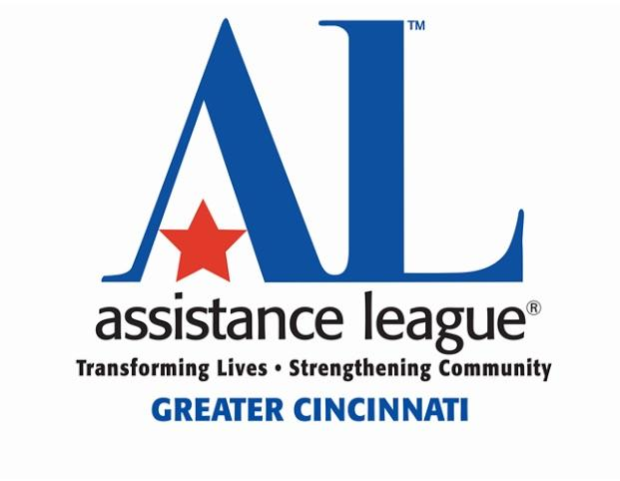
Assistance League Of Greater Cincinnati
New Member Information Form
2024-2025

Name: ________________________________________________________ Date _________________
(Please print clearly)

MEMBERSHIP CATEGORY:

Regular: _____ $80, which includes $60 annual dues and $20 new member fee
($50 December through March, includes $30 annual dues & $20 new member fee.)
Regular members attend as many regular monthly meetings as possible and are encouraged to serve on one or more committees. Regular members are eligible to vote.

Associate: _____ $105, which includes $85 annual dues and $20 new member fee.
($62.50 December through March, includes $42.50 annual dues & $20 new member fee.)
Associate members attend as many regular monthly meetings as possible and serve on as many committees as they have availability.
* Note: Your full dues are tax-deductible. $40 of your membership dues goes directly to National.

Address: _____________________________________________________________________________
Phones #’s: Home: ___________________ Work: ___________________ Cell: ____________________
Email address: _________________________________________________________________________
Birthday (MM/DD): __________ / __________
I heard about Assistance League through: ___________________________________________________
Please indicate by placing an X on the line of one or more committees or programs that interest you:
Committees: _____Membership_____ Fundraising_____ Marketing/Communication_____ Operations
_____ Finance ____E-Commerce _____Technology
Programs: _____ALCares4Kids_____Assault Survivor Kits_____ College Starter Kits
______New Beginnings_____ Operation School Bell

EMERGENCY CONTACT INFORMATION:

Name/Relationship: _____________________________________________________________________
Phones #’s: Home: __________________ Work: __________________ Cell: ____________________

PHOTO AND NAME RELEASE

____ YES ____ NO Assistance League of Greater Cincinnati has my permission to include my name
as a member of and/or donor to Assistance League in its electronic and printed materials. Assistance League also has my permission to use photographs of me taken in connection with Assistance League’s activities in its electronic and printed materials.
TURN OVER TO COMPLETE REMAINDER OF YOUR INFORMATION

INSURANCE

____ YES ____ NO I understand that I shall maintain my own health and accident insurance. Assistance League of Greater Cincinnati is not responsible for any medical or legal expenses that may result fromany injury or illness that I may sustain while participating in Assistance League activities. I further release ALGC from any injuries or illness I may sustain while participating in ALGC activities.

____ YES ____ NO I agree that I shall maintain a valid driver’s license and adequate personal automobile insurance if I am using my own vehicle for Assistance League of Greater Cincinnati business.

CONFLICT OF INTEREST

____ YES ____ NO I have read and agree to abide by the Conflict of Interest and Self Dealing Policies of Assistance League of Greater Cincinnati
Please check 1 box below:

____ I have no conflict(s) of interest to report.
____ I have the following conflict(s) of interest to report:

(examples: you sell similar clothing as our uniforms, you sell insurance to non-profits)
_____________________________________________________________________________________
_____________________________________________________________________________________

BACKGROUND INFORMATION

____ YES ____ NO Have you ever been convicted of or pleaded “no contest” to a felony?
If “YES”, please explain: _________________________________________________________________

Note: No person will be denied membership solely on the grounds of conviction of a criminal offense. The nature of the offense, date of the offense, the surrounding circumstances and the relevance to the activities of the chapter may, however, be considered.

I certify that the information contained in this application is TRUE and COMPLETE.
I understand that false information may be grounds for denying membership in the organization or for immediate termination of membership at any point in the future. I authorize the verification of any or all information listed above.

Signature ________________________________________________ Date ______________________

Send your completed New Member Information Form and check payable to ALGC to:
Attn: Membership VP
Assistance League of Greater Cincinnati
1057 Meta Drive, Cincinnati, OH 45237

Phone: 513-221-4447 Email: information@alcincinnati.org
Website: www.assistanceleaguecincinnati.org

Updated January 2024

